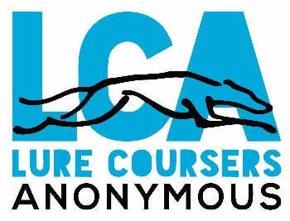

Lure Coursers Anonymous Inc
lurecoursersanonymous@yahoo.com.au
Club: Lure Coursers Anonymous Inc
Type of Event: Lure Coursing Trial
Date & Venue: 18th August 2024, South Western Highway, Waterloo
Judge: Ms Toni Snoeren – All Trial Dogs

Entry Fees: $10 per dog non-member; $5 per dog member
Classes: Trial; Puppy/Training Runs

Gates open: 8am

Sign in by: 9.30am or deemed absent

Judging Order: Trial, followed by Puppy/Training Runs
Trophy: Best on Course

Refreshments: BYO
Enquiries: Email – lurecoursersanonymous@yahoo.com.au
End of Year Awards: Points go towards LCA End of Year Awards – financial members only.

